GOVERNMENT OF INDIA
Ministry of Commerce & Industry | NICDC
Industrial Corridor Project Management System (IC-PMS)

MODULE 2
Scheduling & Planning Engine
(Oracle Primavera P6 / Unifier-Aligned CPM/EVM Framework)
Detailed Design Document

Document Version: 1.0 | March 2026 | Classification: Restricted
Prepared by: IC-PMS Solution Architect Team | NICDC / Ministry of Commerce & Industry

1. Module Overview

1.1 Purpose & Objectives
Module 2 — Scheduling & Planning Engine — is the heartbeat of IC-PMS. It transforms the static WBS hierarchy created in Module 1 into a living, dynamic schedule that drives every construction activity across India's six national industrial corridors. The engine is designed to replicate and extend the core capabilities of Oracle Primavera P6 EPPM and Primavera Unifier's Schedule Manager, while being purpose-built for the regulatory, procedural, and geospatial realities of Indian government infrastructure projects.
The module provides Critical Path Method (CPM) scheduling, Programme Evaluation and Review Technique (PERT) duration estimation, full Earned Value Management (EVM) compliant with ANSI/EIA-748, resource levelling, constraint-based scheduling, multiple baseline management, and predictive analytics using machine learning on schedule performance signals.
Every schedule activity in Module 2 is anchored to a WBS element (from Module 1), linked to physical resource deployments, connected to satellite-derived progress data (from Module 3), and drives the cost commitment and forecasting engine (in Module 4). This integration makes Module 2 the central nervous system of IC-PMS — connecting physical site progress to financial performance and executive dashboards in real time.

1.2 Module Scope
Capability | Included | Primavera Equivalent
Project schedule setup & WBS linkage | Yes | P6 Project Setup / WBS
Activity creation & coding (up to 50,000 activities per corridor) | Yes | P6 Activity Sheet
CPM: Forward pass, Backward pass, Float calculation | Yes | P6 Schedule Calculation
PERT duration estimation (3-point) | Yes | P6 Risk Analysis / Primavera Risk Analysis
Multiple baselines (Original, Current Approved, Working) | Yes | P6 Baseline Manager
Earned Value Management (BCWS, BCWP, ACWP, SPI, CPI, EAC, TCPI, VAC) | Yes | P6 EVM / Unifier Cost Manager
Resource library & resource loading per activity | Yes | P6 Resource Management
Resource histogram & levelling | Yes | P6 Resource Leveling
Look-ahead windows (4-week, 13-week rolling) | Yes | P6 Short-Interval Schedule
Schedule compression: Fast-track, Crashing, What-If | Yes | P6 What-If / Oracle Risk
Satellite progress integration (% complete auto-update) | Yes | IC-PMS Extension (Module 3)
Schedule Health Index | Yes | IC-PMS Extension (NICDC KPI)
Export: P6 XER, MS Project XML, PDF Gantt, Excel | Yes | P6 native formats
Natural language schedule queries (LLM-powered) | Yes | IC-PMS Extension
Resource cost integration | Yes | Links to Module 4

1.3 Key Design Principles
- Primavera P6 data model compatibility: Activity, Relationship, Resource Assignment, Baseline, and Calendar entities mirror P6 XER schema for seamless import/export
- CPM-first: All schedule calculations use CPM as the authoritative baseline; PERT and Monte Carlo are additive risk layers
- Single data date: Every corridor schedule has one current 'data date' — the statusing date against which all EVM calculations are performed
- Immutable baselines: Approved baselines are locked; any variance must be documented with a Root Cause Analysis (RCA) before a new baseline can be approved
- Satellite truth: AI-derived physical % complete from satellite imagery (Module 3) is the authoritative source for EVM physical progress — overriding self-reported contractor data unless an override is approved by PMC
- Resource-loaded schedules: No activity can be published without at least one resource assignment — ensuring schedules are realistic and resource-constrained

2. Sub-Functions — Detailed Requirements

2.1 Sub-Function 2.1 — Schedule Setup & Initialisation
This sub-function creates the schedule header record — the administrative container for all activities, baselines, and progress records within a project schedule. Each project (from Module 1) may have multiple schedule versions but only one 'Current' schedule at any point in time.

Functional Requirements
- Schedule creation wizard: Link to Project Master (Module 1), select Project Phase, set Data Date, select working Calendar, define scheduling options (retained logic vs. progress override, out-of-sequence handling)
- Calendar configuration: Working hours per day, working days per week (5-day/6-day options), state-specific public holidays (pre-loaded for all 28 states and 8 UTs), shift patterns (single/double/triple shift)
- Multiple calendars per project: Resource calendars, activity calendars, project calendar — following P6 calendar hierarchy
- Schedule options: Retained logic (default), progress override (for fast-tracked works), actual dates (for as-built capture)
- Activity code dictionaries: Configurable code sets for Phase, Discipline, Zone, Asset Type, Contractor — enabling multi-dimensional schedule filtering
- Schedule status lifecycle: Draft → Submitted → Approved → Current → Archived
- Import from P6 XER and MS Project XML as alternative to manual entry

Calendar Master Data
Calendar Type | Working Days | Use Case | State-specific Holiday Support
Standard – 5 Day | Mon–Fri, 8 hrs/day | Office/PMC activities | Yes – Gazetted holidays
Construction – 6 Day | Mon–Sat, 10 hrs/day | Civil construction works | Yes – Major festivals only
Construction – 7 Day | Mon–Sun, 12 hrs/day | Critical path, monsoon catch-up | No holiday exceptions
Equipment – Continuous | 24 hrs/day, 7 days | Batching plants, cranes | No exceptions
Monsoon-Adjusted | Mon–Sat, minus Jun–Sep | Outdoor civil works in flood zones | Regional Monsoon calendar

2.2 Sub-Function 2.2 — Activity Builder
The Activity Builder is the primary data entry interface for creating and editing individual schedule activities — the atomic units of work in IC-PMS. An 'Activity' in IC-PMS corresponds directly to a P6 Activity, with all the same attributes plus IC-PMS extensions for satellite linkage and NIC coding.

Functional Requirements
- Activity types: Task Dependent, Resource Dependent, Level of Effort, Start Milestone, Finish Milestone — following P6 activity types
- Duration types: Fixed Duration & Units (FDU), Fixed Duration & Units/Time (FDT), Fixed Units (FU), Fixed Units/Time (FUT) — P6-compatible
- PERT three-point duration entry: Optimistic (O), Most Likely (M), Pessimistic (P) → PERT Expected = (O + 4M + P) / 6; Standard Deviation = (P – O) / 6
- Predecessor/Successor dependency entry: Finish-to-Start (FS), Start-to-Start (SS), Finish-to-Finish (FF), Start-to-Finish (SF) with positive/negative lag in days
- WBS linkage: Every activity must be linked to a Level 5+ WBS element (Work Package or below); summary activities auto-roll up to WBS summary levels
- Resource assignment: One or more resources assigned per activity with planned units; resource calendar applies to activity dates
- Cost loading: Resource cost rates from Resource Library automatically calculate planned cost per activity (Budget Cost = Units × Rate)
- Constraint types: As Late As Possible (ALAP), As Soon As Possible (ASAP), Must Start On (MSO), Must Finish On (MFO), Start No Earlier Than (SNET), Start No Later Than (SNLT), Finish No Earlier Than (FNET), Finish No Later Than (FNLT)
- Suspend/Resume: Activities can be suspended (paused mid-execution) and resumed, with actual start/finish dates maintained
- Activity notebook: Free-text notes, attachments, and risk flag per activity — linked to Module 6 DMS

Activity — Key Data Fields
Field | Type | Description | P6 Equivalent
activity_id | UUID PK | Unique system identifier | Activity ID
act_code | VARCHAR(30) | NIC-format code: {WBS}-{SEQ} | Activity Code
act_name | VARCHAR(200) | Descriptive activity name | Activity Name
act_type | ENUM | Task Dep./Resource Dep./LOE/Milestone | Activity Type
duration_type | ENUM | FDU / FDT / FU / FUT | Duration Type
original_duration | INTEGER | Baseline duration in working days | Original Duration
remaining_duration | INTEGER | Updated remaining duration | Remaining Duration
pct_complete | DECIMAL(5,2) | Physical % complete (0–100) | Activity % Complete
planned_start | DATE | CPM-calculated planned start | Planned Start
planned_finish | DATE | CPM-calculated planned finish | Planned Finish
actual_start | DATE | Set when work begins | Actual Start
actual_finish | DATE | Set when activity is complete | Actual Finish
early_start/early_finish | DATE | Forward pass results | Early Start / Early Finish
late_start/late_finish | DATE | Backward pass results | Late Start / Late Finish
total_float | INTEGER | LS – ES (critical if 0) | Total Float
free_float | INTEGER | Float without delaying successors | Free Float
is_critical | BOOLEAN | True if Total Float ≤ 0 | Critical Flag
wbs_id | FK | Linked WBS element | WBS
calendar_id | FK | Activity calendar | Calendar
constraint_type | ENUM | ASAP/ALAP/MSO/MFO etc. | Constraint Type
constraint_date | DATE | Date for MSO/MFO/SNET etc. | Constraint Date
satellite_progress_pct | DECIMAL | % from Module 3 AI — authoritative | IC-PMS extension

2.3 Sub-Function 2.3 — CPM/PERT Scheduling Engine
The CPM engine is the computational core of Module 2. It executes the critical path calculation on the complete activity network, producing Early Start, Early Finish, Late Start, Late Finish, Total Float, and Free Float for every activity — and identifying the critical path (or paths) through the network.

CPM Calculation Algorithm
- Topological Sort: All activities are sorted into a directed acyclic graph (DAG) using Kahn's algorithm. Cyclic dependencies are detected and reported as errors before calculation proceeds.
- Forward Pass: Working from the project start, for each activity: Early Start = max(Early Finish of all predecessors + lag). Early Finish = Early Start + Duration. Constraint dates applied: if SNET constraint exists, Early Start = max(Early Start, SNET Date).
- Backward Pass: Working from the project end (Latest Finish = target completion date): Late Finish = min(Late Start of all successors - lag). Late Start = Late Finish - Duration. MFO/FNLT constraints applied at Late Finish.
- Float Calculation: Total Float = Late Start - Early Start (or Late Finish - Early Finish). Free Float = min(Early Start of successors) - Early Finish. Negative float indicates a constraint violation or missed target date.
- Critical Path Identification: All activities with Total Float = 0 (or ≤ user-defined threshold, default 0) are marked Critical. Multiple critical paths are supported.
- Schedule Health Metrics: After CPM, the engine computes: Schedule Compression Ratio (Critical Activities / Total Activities × 100), Total Float Distribution Histogram, Near-Critical Path count (Float ≤ 7 days).

PERT Integration
In addition to deterministic CPM, the engine supports PERT (Programme Evaluation and Review Technique) for probabilistic duration modelling on high-uncertainty activities (typically activities with >30 days duration or classified as High Risk in Module 7).
- Three-point estimates: Optimistic (O), Most Likely (M), Pessimistic (P) per activity
- PERT Expected Duration (te) = (O + 4M + P) / 6
- PERT Standard Deviation (σ) = (P – O) / 6
- Project completion probability curves: Monte Carlo simulation (minimum 10,000 iterations) on all PERT-enabled activities produces P50 and P80 completion dates
- Sensitivity analysis: Tornado chart showing which activities contribute most to schedule uncertainty

2.4 Sub-Function 2.4 — Baseline Manager
The Baseline Manager stores and compares multiple versions of the project schedule — providing the ability to track schedule variance, understand the impact of scope changes, and maintain an authoritative record for audit and contract purposes.

Baseline Types
Baseline Type | Purpose | Edit Permitted | Approval Required
Original Baseline (BL0) | The first approved schedule; project contract baseline | No (locked) | NICDC Programme Director + SPV Director
Current Approved Baseline (BL-CA) | Most recently approved revision; used for EVM calculation | No (locked until revision approved) | SPV Director
Working Baseline (BL-W) | Active working schedule being statused; updated daily/weekly | Yes | None — working only
What-If Baseline (BL-WI) | Scenario analysis; fast-track or crash scenario | Yes | None — analysis only, not official
As-Built (AB) | Post-project record of actual dates; created at project close | No (final record) | NICDC PM Director

Variance Analysis — Key Metrics
Metric | Formula | Reporting Level | Alert Threshold
Schedule Variance (SV) | BCWP – BCWS | Activity, Package, Project | SV < -5% of BCWS
Start Variance (SV days) | Planned Start – Actual Start | Activity | SV > 7 days
Finish Variance (FV days) | Planned Finish – Forecast Finish | Activity | FV > 14 days
Duration Growth % | (Actual Duration – Planned Duration) / Planned Duration × 100 | Activity | > 20% growth
Baseline Change Count | No. of approved revisions to BL-CA | Project | > 3 revisions triggers review

2.5 Sub-Function 2.5 — Resource Loader
The Resource Loader manages the complete lifecycle of resource planning, assignment, and tracking. It enables resource-loaded schedules — a mandatory requirement for IC-PMS — ensuring that every scheduled activity has defined labour, equipment, and material requirements, enabling realistic schedule development and cash flow forecasting.

Resource Types Supported
Resource Type | Unit | Cost Integration | Examples
Labour – Skilled | Persons / Gang | Daily rate × deployment days | Masons, Carpenters, Electricians, Surveyors
Labour – Semi-Skilled | Persons | Daily rate × days | Bar benders, Shuttering workers
Labour – Unskilled | Persons | Daily rate × days | Helpers, Earthmovers
Equipment | Units (No.) | Hire rate/day or owned depreciation | Excavators, Cranes, Batching Plants, Pavers
Material – Permanent | MT / Sqm / m3 / LS | Unit rate from SOR / Market rate | Steel, Cement, Aggregate, Bitumen, Pipe
Material – Consumable | LS | Lump sum per activity | Formwork oil, Wire mesh, Nails
Subcontractor | LS / % of contract | Contract value × % complete | Specialist packages

Functional Requirements
- Resource library: Pre-loaded with CPWD Schedule of Rates (SOR) 2024-25 rates for all resource types, state-wise DSR rates linkable
- Resource availability calendar: Each resource has an availability profile (max units per period) with global, project-level, and activity-level allocation tracking
- Over-allocation detection: System flags activities where resource demand exceeds availability in any period; colour-coded in resource histogram
- Resource levelling: Automated levelling algorithm (within total float) resolves over-allocations without extending the project end date where possible; manual override supported
- Resource histogram: Bar chart showing planned vs. actual vs. remaining resource deployment per period, per resource type, per WBS scope
- Resource substitution: If a resource becomes unavailable, system suggests equivalent resources from the library with cost impact calculation
- Bulk assignment: Apply a resource loading template to multiple selected activities simultaneously

2.6 Sub-Function 2.6 — EVM Calculator
The EVM Calculator computes the full suite of Earned Value Management metrics at every level of the WBS hierarchy — from individual activity to full corridor programme — as of the current Data Date. Calculations are fully compliant with ANSI/EIA-748 and replicate the EVM module of Oracle Primavera Unifier.

EVM Metric Definitions
Metric | Full Name | Formula | Interpretation
BCWS | Budget Cost of Work Scheduled | Budget × Time-phased % planned to date | Planned Value: what we planned to spend
BCWP | Budget Cost of Work Performed | Budget × Physical % Complete | Earned Value: budget value of work done
ACWP | Actual Cost of Work Performed | Sum of actual invoices posted (from Module 4) | Actual Cost: what we actually spent
SPI | Schedule Performance Index | BCWP / BCWS | <1 = behind schedule; >1 = ahead
CPI | Cost Performance Index | BCWP / ACWP | <1 = over budget; >1 = under budget
SV | Schedule Variance | BCWP – BCWS | Negative = schedule delay in cost terms
CV | Cost Variance | BCWP – ACWP | Negative = cost overrun
EAC | Estimate at Completion | BAC / CPI (or ACWP + ETC) | Total predicted cost at completion
ETC | Estimate to Complete | EAC – ACWP | Remaining cost to finish project
VAC | Variance at Completion | BAC – EAC | Positive = under budget at end
TCPI | To-Complete Performance Index | (BAC–BCWP)/(BAC–ACWP) | Efficiency needed to finish on budget
BAC | Budget at Completion | Sum of all baseline budget costs | Total approved project budget

EVM Reporting Thresholds (Traffic Lights)
Metric | Green (On Track) | Amber (At Risk) | Red (Off Track) | Escalation
SPI | ≥ 0.95 | 0.85–0.94 | < 0.85 | Report to SPV Director weekly
CPI | ≥ 0.95 | 0.85–0.94 | < 0.85 | Report to NICDC Finance monthly
TCPI | ≤ 1.05 | 1.06–1.10 | > 1.10 | Trigger RCE process if TCPI > 1.10
VAC % | Positive | –5% to 0% | < –5% | Ministry note if VAC < –10%
EAC vs BAC | +/–5% | +5% to +10% | > +10% | CCEA information note if > +20%

2.7 Sub-Function 2.7 — Progress Updater
The Progress Updater integrates actual construction progress from multiple sources — satellite imagery, field mobile app entry, and PMC certification — to maintain a single authoritative physical % complete for every activity. It is the data pipeline that keeps the schedule alive and EVM calculations current.

Progress Data Sources — Priority Order
- Satellite AI Progress (Primary): AI/ML-derived physical % complete from Module 3 imagery analysis. Source: Semantic segmentation of Cartosat-3/Planet imagery over WBS geo-polygon. Updated: Weekly. Authority: Overrides contractor-reported progress unless a PMC-approved override is in place.
- PMC Field Inspection (Authoritative Override): Certified progress from PMC site engineer following physical inspection. Updated: Fortnightly minimum; after each milestone. Authority: Can override satellite data for activities inside structures (where satellite has limited visibility).
- Contractor Daily Progress Report (DPR): Contractor-submitted daily progress log via mobile app or web form. Updated: Daily. Authority: Advisory — flagged if diverges >10% from satellite data; subject to PMC approval.
- Measurement Book (MB) Certified Quantities: Quantities measured by PMC from approved MB entries (Running Account Bills). Updated: Per RA Bill cycle (typically monthly). Authority: Highest — used as final actual for financial EVM.

Progress Update Workflow
- Weekly: Satellite imagery triggers auto-update of satellite_progress_pct for all active activities in active WBS polygons
- System compares satellite_progress_pct with contractor-reported pct_complete; if divergence > 10%, generates discrepancy alert to PMC
- PMC reviews discrepancy and approves satellite figure, approves contractor figure with justification, or records certified_progress_pct after field visit
- Approved progress propagates to EVM calculator: Updates BCWP for the activity; rolls up to WBS parents; triggers S-curve update
- Data date advance: NICDC Programme Manager advances the data date weekly (typically every Monday) to trigger EVM recalculation across all active schedules

2.8 Sub-Function 2.8 — Look-ahead Generator
The Look-ahead Generator produces short-interval schedule windows for operational planning — the daily and weekly working tool for site engineers and PMCs. It extracts activities that should be starting, in progress, or finishing within the look-ahead window and packages them as executable work plans.

Look-ahead Window Types
Window Type | Horizon | Audience | Output Format | Update Frequency
4-Week Look-ahead | 28 calendar days from data date | Site Foreman / Contractor | PDF / Excel work plan, WhatsApp summary | Weekly (every Monday)
13-Week Look-ahead | 91 calendar days from data date | PMC / SPV Operations | PDF Gantt + resource loading table | Fortnightly
Monthly Planning Window | Current calendar month | SPV Programme Manager | PowerPoint slide deck + EVM forecast | Monthly (first week)
Recovery Schedule | Custom (post-delay) | NICDC when project is Red | Compressed Gantt with crash analysis | On demand (ad hoc)

Functional Requirements
- Activities appearing in look-ahead are those with: Early Start within the window, or activities already in-progress, or activities with Total Float ≤ (window duration × 0.5)
- Look-ahead includes: Activity name, code, WBS, planned start/finish, current % complete, responsible contractor, resource requirements for the window
- Critical Path activities highlighted in red in all look-ahead formats
- Resource-demand summary table: Aggregate labour, equipment, and material requirements per week within the window
- WhatsApp integration (Module 3 extension): Weekly 4-week look-ahead auto-formatted as a condensed WhatsApp message for field supervisors
- 'Plan vs. Actual' comparison in look-ahead: Previous week's planned activities compared against actual completions; variance items carried forward

3. Data Flow Diagrams

3.1 DFD Level 0 — Context Diagram
The Context Diagram presents Module 2 as the central Scheduling & Planning Engine (Process 2.0) receiving WBS structures from Module 1, satellite progress from Module 3, cost actuals from Module 4, and field inputs from contractors. It feeds schedule intelligence upward to NICDC HQ dashboards and outward to the Primavera P6/MS Project ecosystem.
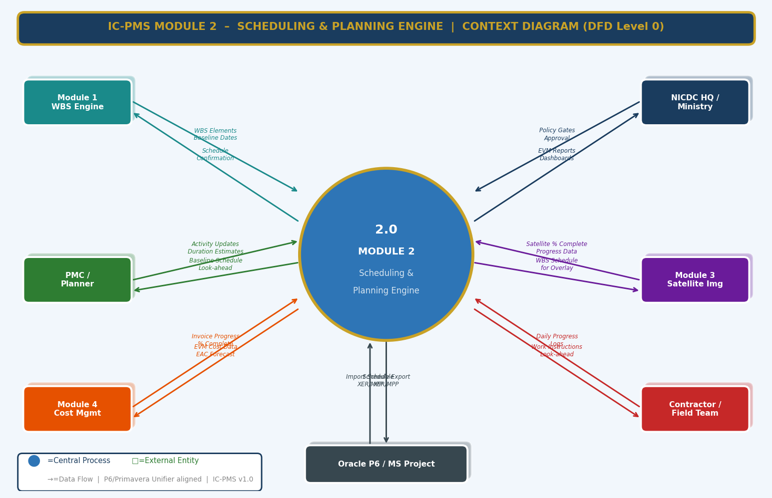
Figure 3.1 — DFD Level 0: Module 2 Context Diagram (All External Data Flows)

External Entity Data Flow Summary
External Entity | Inputs to Module 2 | Outputs from Module 2
Module 1 — WBS Engine | WBS Element hierarchy, Baseline dates, OBS structure, Project code | Schedule confirmation, Activity stubs linked to WBS, Baseline acknowledgement
NICDC HQ / Ministry | Policy-driven completion gates, Approval decisions on baseline revisions | EVM executive dashboards, S-curves, TCPI alerts, Programme health reports
PMC / Planner | Activity definitions, Duration estimates, Predecessor-successor logic, Resource assignments | Approved schedule, Look-ahead windows, Resource loading plan
Module 3 — Satellite | AI-derived physical % complete per WBS polygon, Change detection reports | WBS schedule polygons for satellite overlay, Data date for scene ordering
Module 4 — Cost Management | Invoice-based ACWP, Resource cost actuals | Budget-linked EVM parameters, EAC forecast, Activity-level planned cost
Contractor / Field Team | Daily progress logs (via mobile app), Suspension/resume events | 4-week look-ahead, Work instructions, Resource deployment plan
Oracle P6 / MS Project | XER/MPP schedule import | XER/MPP schedule export, PDF Gantt

3.2 DFD Level 1 — Main Processes & Data Stores
The Level 1 DFD decomposes Module 2 into eight core processes and eight data stores. The processes span the complete scheduling lifecycle from initial schedule setup through CPM calculation, EVM analytics, resource management, progress updating, and look-ahead generation.
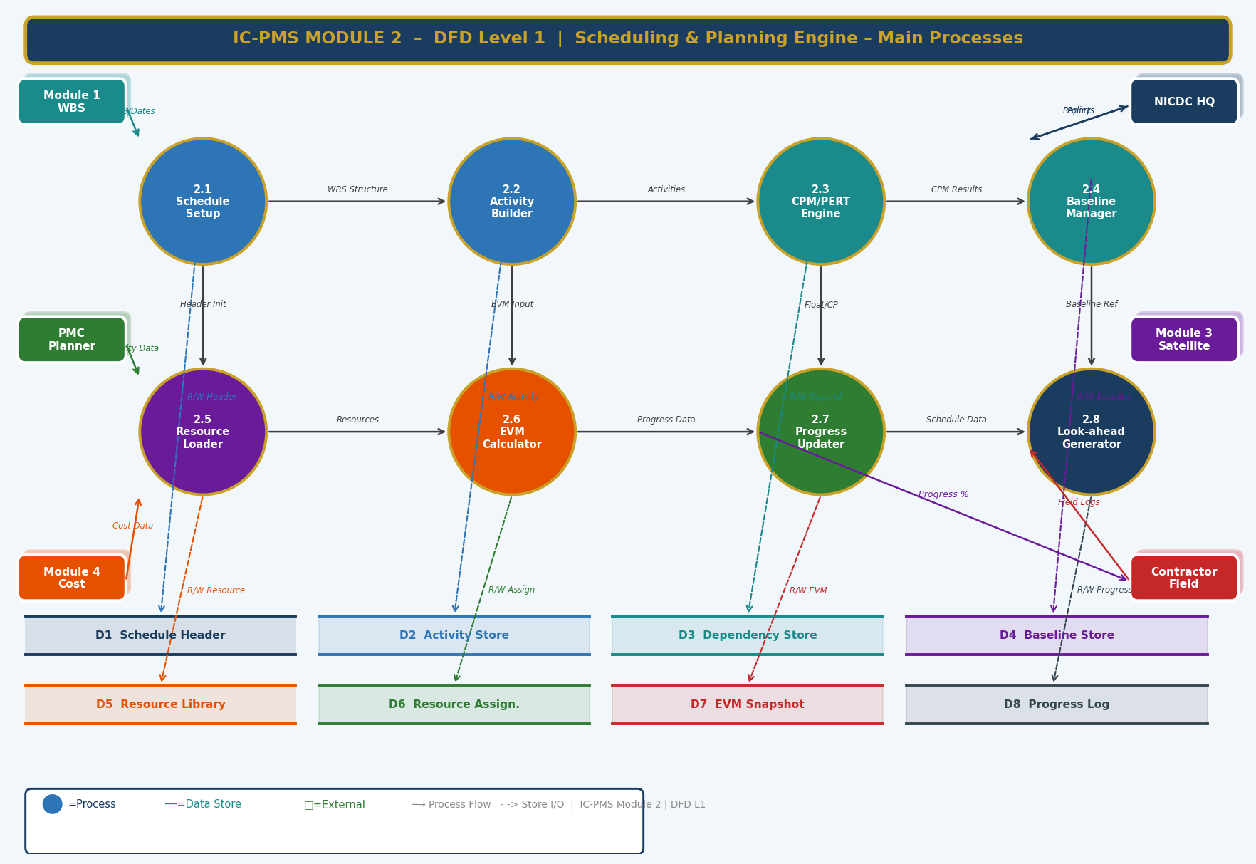
Figure 3.2 — DFD Level 1: Eight Core Processes and Eight Data Stores

Process Descriptions
Process | Name | Primary Function
2.1 | Schedule Setup | Creates schedule header, configures calendars, sets data date and scheduling options
2.2 | Activity Builder | Creates/edits activities, assigns dependencies, resources, constraints, and WBS links
2.3 | CPM/PERT Engine | Executes forward/backward pass, computes float, identifies critical path, runs PERT simulation
2.4 | Baseline Manager | Stores, locks, and compares schedule baselines; manages revision approval workflow
2.5 | Resource Loader | Assigns resources to activities, tracks availability, detects over-allocation, runs levelling
2.6 | EVM Calculator | Computes BCWS/BCWP/ACWP and all derived EVM metrics; updates S-curves and dashboards
2.7 | Progress Updater | Integrates satellite, PMC, contractor progress data; resolves conflicts; advances data date
2.8 | Look-ahead Generator | Produces 4-week and 13-week rolling look-ahead schedules; exports to PDF/Excel/WhatsApp

Data Store Descriptions
Store | Contents
D1 — Schedule Header | Project schedule metadata, data date, status, scheduling options, calendar linkage
D2 — Activity Store | All activity records with CPM results (ES, EF, LS, LF, Float), progress, constraints
D3 — Dependency Store | Predecessor-successor relationships with type (FS/SS/FF/SF) and lag values
D4 — Baseline Store | Locked schedule snapshots per baseline type with all activity dates at time of approval
D5 — Resource Library | Resource master catalogue: code, name, type, unit, cost rates, availability profile
D6 — Resource Assignments | Per-activity-per-resource planned units, budgeted cost, actual units consumed
D7 — EVM Snapshot | Time-phased BCWS, BCWP, ACWP and all derived EVM metrics per data date
D8 — Progress Log | Historical record of all progress updates by source (satellite/PMC/contractor/MB)

3.3 DFD Level 2 — Process 2.3: CPM/PERT Engine (Exploded)
The Level 2 diagram drills into the CPM/PERT Engine — the most computationally complex process in Module 2. It shows all eight sub-processes from activity network loading through health index calculation, including the decision diamond for schedule feasibility checking.
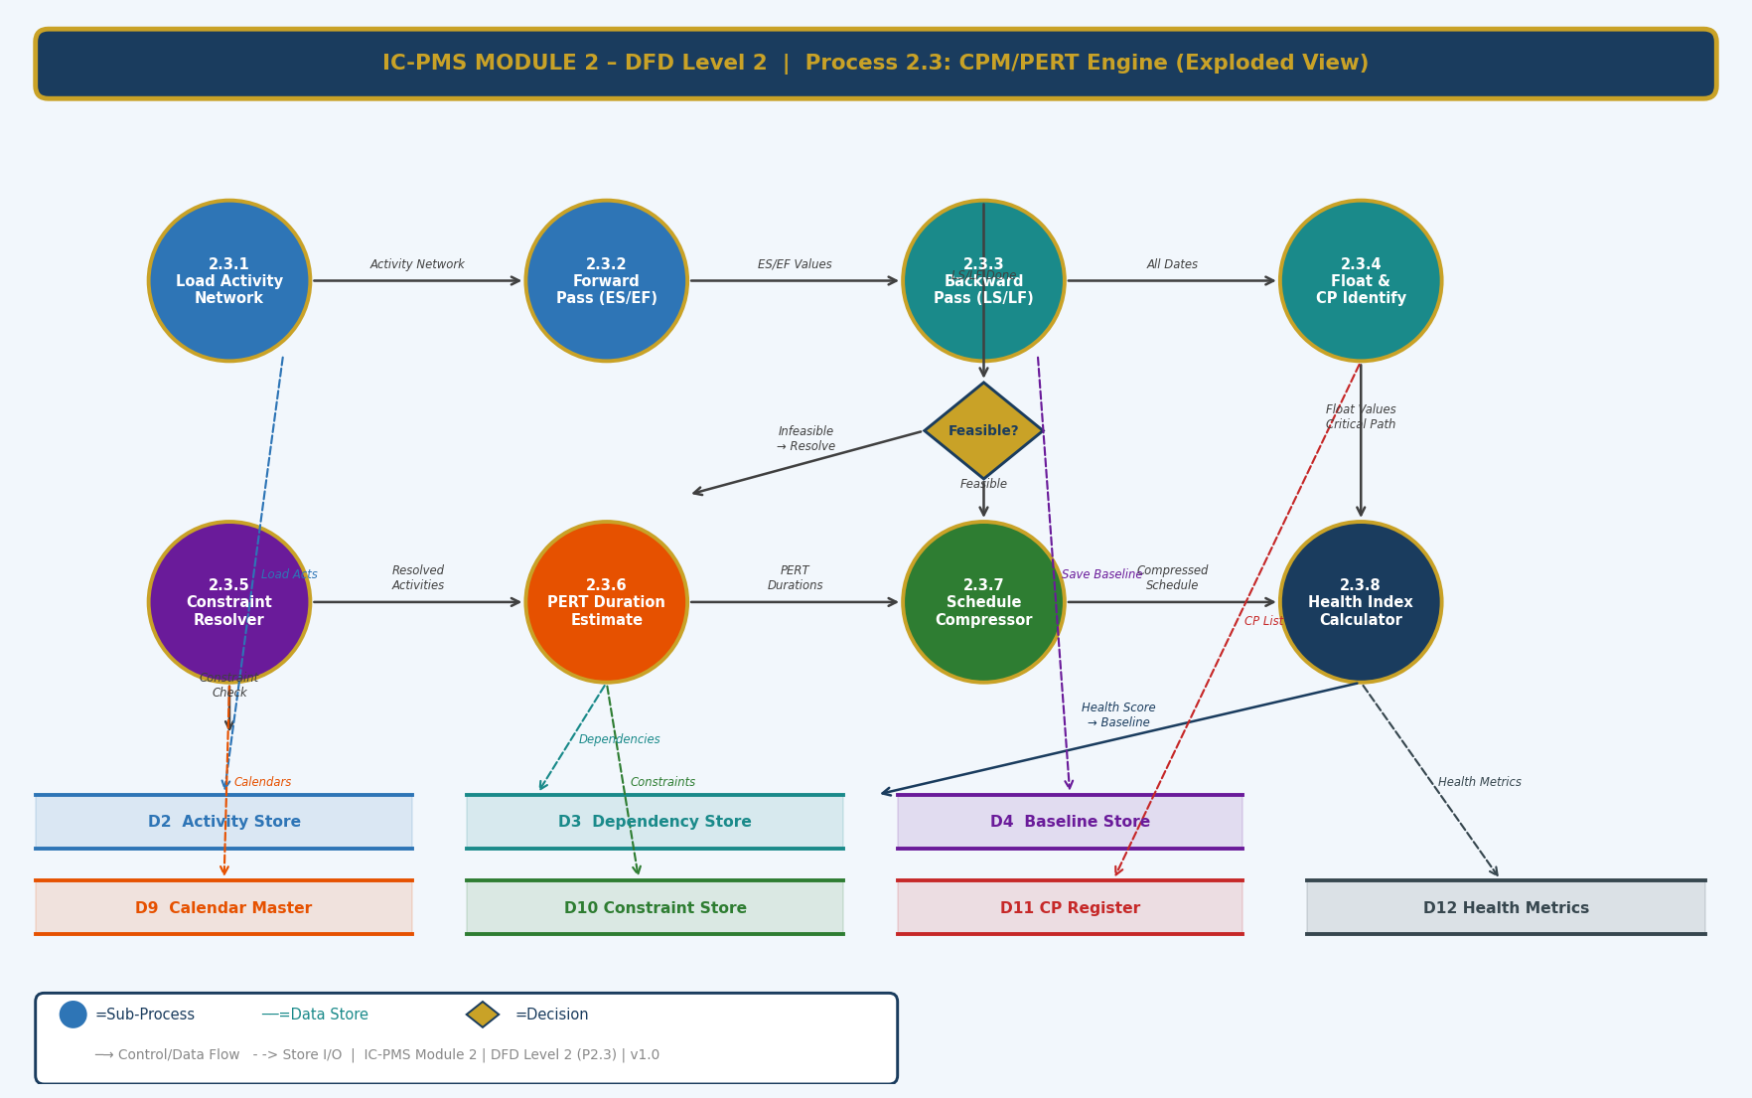
Figure 3.3 — DFD Level 2: Process 2.3 CPM/PERT Engine — 8 Sub-Processes with Decision Logic

Sub-Process Narrative
Sub-Process | Name | Description
2.3.1 | Load Activity Network | Reads all activities and dependencies from D2 and D3 for the selected schedule. Validates that the network forms a valid DAG (no cycles). Builds in-memory adjacency list for CPM traversal.
2.3.2 | Forward Pass | Iterates activities in topological order. Computes Early Start = max(Predecessor Early Finish + Lag); Early Finish = Early Start + Duration. Applies SNET/MSO constraints. Stores ES/EF in D2.
2.3.3 | Backward Pass | Iterates activities in reverse topological order. Computes Late Finish = min(Successor Late Start – Lag); Late Start = Late Finish – Duration. Applies MFO/FNLT constraints. Stores LS/LF in D2.
2.3.4 | Float & CP Identification | Computes Total Float = LS – ES for each activity. Identifies Critical Path (TF ≤ 0). Computes Free Float. Writes CP flag and float values to D2. Registers critical activities in D11 (CP Register).
2.3.5 | Constraint Resolver | Checks all activities against their constraint dates (from D10). If constraint creates negative float, generates a 'constraint violation' event and reroutes to feasibility decision. Applies ALAP logic to non-critical activities.
2.3.6 | PERT Duration Estimator | For activities with PERT three-point estimates enabled, computes te = (O+4M+P)/6 and σ = (P–O)/6. Runs Monte Carlo (10,000 iterations) to generate P50/P80 project completion dates. Stores distribution results.
2.3.7 | Schedule Compressor | If schedule is infeasible (negative float on critical path), offers fast-track (overlap FS to SS) and crashing (add resources to shorten critical activities) options. Presents What-If comparison to user.
2.3.8 | Health Index Calculator | Computes Schedule Health Index (SHI): SHI = 100 × (1 – CP_activities/total_activities) × CPI_weight × SPI_weight × float_distribution_weight. Writes health score to D12 and weekly trend to dashboard.

4. Master Data Model

4.1 Entity Relationship Overview
The Module 2 master data model contains twelve entities. The Schedule Header is the root entity; Activity is the central entity to which dependencies, resources, progress, and baselines all connect. The model is designed for direct compatibility with the Oracle Primavera P6 XER schema.
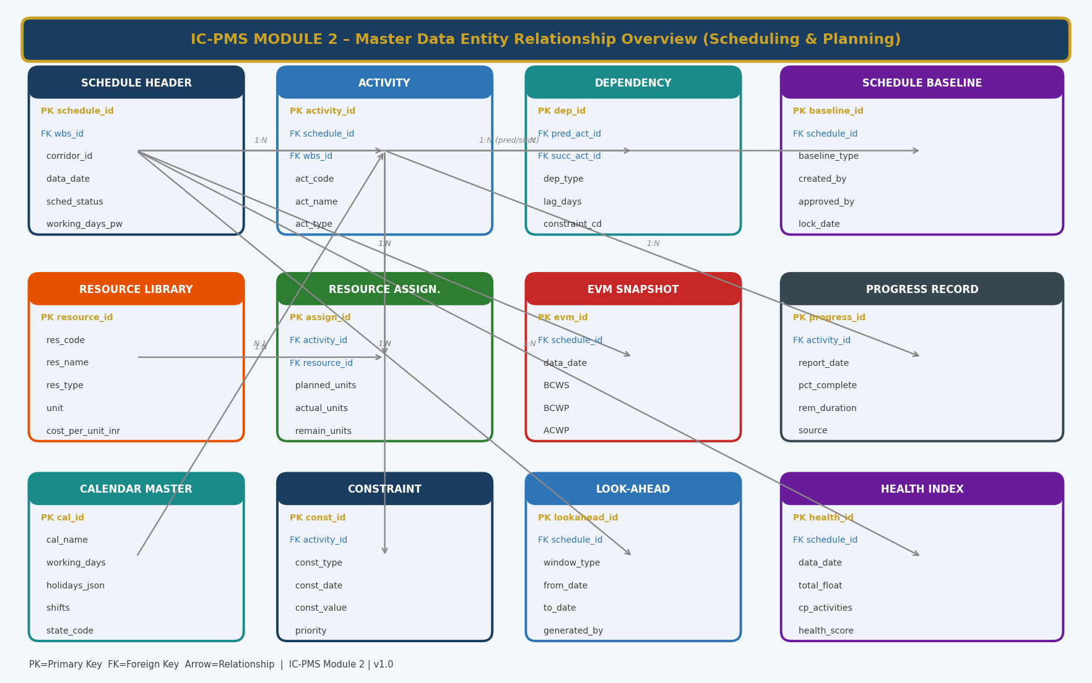
Figure 4.1 — Master Data Entity Relationship Overview (Module 2 — Scheduling & Planning)

4.2 Core Entity Field Definitions

4.2.1 Schedule Header
schedule_id | UUID — Primary Key; auto-generated
wbs_id / project_id | FK → Module 1 Project Master and WBS Level 1 root
schedule_name | Descriptive schedule name (e.g. 'DMIC-N03 Construction Phase v3')
data_date | DATE — The current statusing date; EVM calculations as of this date
project_planned_start | DATE — Planned project start (from WBS baseline)
project_planned_finish | DATE — Planned project completion target
sched_status | ENUM: Draft / Submitted / Approved / Current / Archived
calendar_id | FK → Calendar Master — project-level working calendar
scheduling_option | ENUM: Retained Logic / Progress Override / Actual Dates
float_type | ENUM: Finish Float / Start Float (Total Float basis)
cp_threshold_days | INTEGER — Float value at or below which activities are deemed Critical (default 0)
working_days_per_week | INTEGER — 5 or 6; overridable per resource calendar

4.2.2 Activity (selected fields — full table in Section 2.2)
activity_id | UUID — Primary Key
schedule_id | FK → Schedule Header
wbs_id | FK → Module 1 WBS Element (Level 5 or below)
act_code / act_name | NIC-format code and descriptive name
act_type / duration_type | Enum values — P6 compatible
original_duration / remaining_duration | Days; remaining updated on every progress entry
pct_complete / satellite_progress_pct | Physical % complete (contractor reported) and AI-satellite derived
early_start / early_finish | CPM forward-pass results
late_start / late_finish | CPM backward-pass results
total_float / free_float | Float in working days; Total Float ≤ 0 = Critical
is_critical | BOOLEAN — flagged by CPM engine
pert_optimistic / pert_likely / pert_pessimistic | Three-point duration estimates in days
constraint_type / constraint_date | P6-compatible constraint codes and dates
calendar_id | FK → Calendar Master — activity-level calendar override

4.2.3 Dependency (Predecessor-Successor Relationship)
dep_id | UUID — Primary Key
pred_act_id | FK → Activity (predecessor)
succ_act_id | FK → Activity (successor)
dep_type | ENUM: FS / SS / FF / SF
lag_days | INTEGER — positive (lag) or negative (lead)
lag_type | ENUM: Physical Days / Working Days / Calendar Days
constraint_cd | VARCHAR — additional external constraint code if applicable (e.g. 'MFO-GOVT-APPROVAL')
is_driving | BOOLEAN — true if this relationship is on the critical/driving path (computed by CPM)

4.2.4 Schedule Baseline
baseline_id | UUID — Primary Key
schedule_id | FK → Schedule Header
baseline_type | ENUM: BL0 (Original) / BL-CA (Current Approved) / BL-W (Working) / BL-WI (What-If) / AB (As-Built)
baseline_name | Descriptive name (e.g. 'Post-Monsoon Recovery Baseline v2')
created_date | TIMESTAMP — when snapshot was created
approved_by | FK → User — NICDC/SPV approver
lock_date | TIMESTAMP — when baseline was locked; NULL if Working or What-If
rca_doc_id | FK → Module 6 DMS — Root Cause Analysis document for baseline revision
activity_snapshot_json | JSONB — complete snapshot of all activity dates at baseline creation
total_duration_days | INTEGER — total schedule duration from start to planned finish
is_current_approved | BOOLEAN — only one BL-CA per schedule can be true

4.2.5 Resource Library
resource_id | UUID — Primary Key
res_code | Unique code (e.g. LAB-MASON-SK, EQP-EXCAV-20T, MAT-CEMENT-OPC)
res_name | Descriptive name
res_type | ENUM: Labour-Skilled / Labour-Semi / Labour-Unskilled / Equipment / Material-Permanent / Material-Consumable / Subcontractor
unit | VARCHAR — Gang / Person / No. / MT / Sqm / m3 / LS
cost_per_unit_inr | DECIMAL — from CPWD SOR 2024-25 or project-specific rate
sor_reference | VARCHAR — SOR item number for rate justification
max_availability | DECIMAL — maximum units available project-wide (enforced by levelling)
calendar_id | FK → Calendar Master — resource-specific working calendar
state_code | VARCHAR — if rate varies by state (some DSR items)

4.2.6 EVM Snapshot
evm_id | UUID — Primary Key
schedule_id | FK → Schedule Header
data_date | DATE — the statusing date for this EVM record
wbs_id | FK — scope of the EVM record (project/corridor/node/package)
BAC | DECIMAL — Budget At Completion for this scope
BCWS | DECIMAL — Budget Cost of Work Scheduled (Planned Value)
BCWP | DECIMAL — Budget Cost of Work Performed (Earned Value)
ACWP | DECIMAL — Actual Cost of Work Performed (from Module 4)
SPI | DECIMAL — BCWP / BCWS
CPI | DECIMAL — BCWP / ACWP
SV | DECIMAL — BCWP – BCWS (Schedule Variance in ₹ Cr)
CV | DECIMAL — BCWP – ACWP (Cost Variance in ₹ Cr)
EAC | DECIMAL — BAC / CPI
ETC | DECIMAL — EAC – ACWP
VAC | DECIMAL — BAC – EAC
TCPI | DECIMAL — (BAC – BCWP) / (BAC – ACWP)

5. UI/UX Screen Designs
Module 2 delivers five primary screens covering the main scheduling workflows. The design language is consistent with Module 1 — dark-navy sidebar, gold accent, teal/blue primary colours — with a focus on information density appropriate for planning professionals. The Gantt view is the most complex screen in IC-PMS and is optimised for 27-inch monitors used by PMC planners, while the Dashboard and EVM screens are designed for executive tablet viewing.

Screen 1 — Module 2 Dashboard
The scheduling dashboard provides an instant programme health snapshot: EVM KPI cards, a comparison S-curve (Planned vs. Actual vs. Forecast), the Critical Path activity list, and an activity status summary bar. It is the first screen opened by NICDC Programme Managers and SPV Directors on Monday mornings.
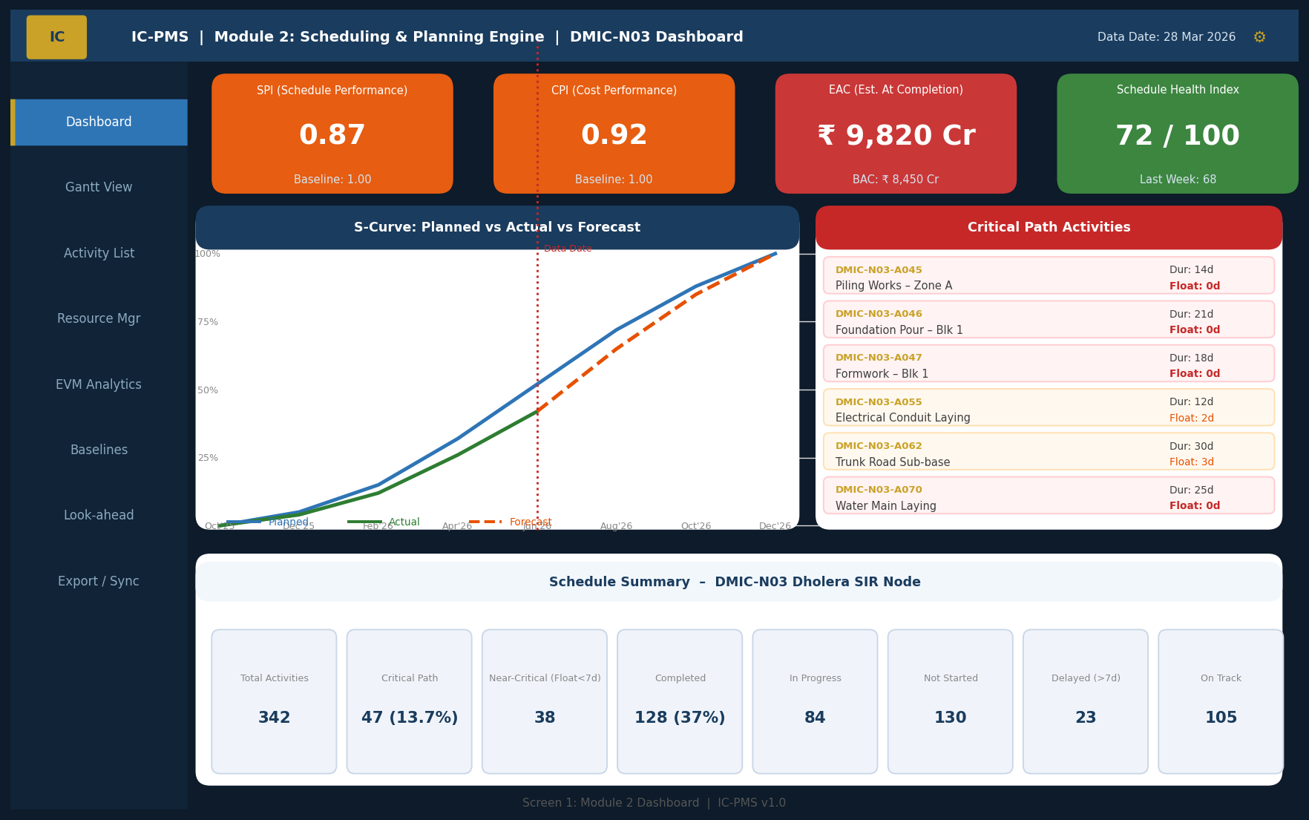
Figure 5.1 — Module 2 Dashboard (EVM KPIs, S-Curve, Critical Path List, Activity Summary)

Dashboard UI Components
Component | Description | Interaction
EVM KPI Cards (top row) | SPI, CPI, EAC, Schedule Health Index displayed as large-number cards with colour-coded RAG status and baseline reference values | Click to drill into EVM Analytics (Screen 5)
S-Curve Chart | Three lines: Planned (BCWS blue), Actual (BCWP green), Forecast (orange dashed). Shaded areas show Cost Variance (red) and Schedule Variance (amber). Data date shown as red vertical line. | Hover for monthly values; click a month to see period detail
Critical Path Activities | Sorted list of CP activities with code, name, duration, and float. RED highlight for TF=0; ORANGE for TF≤3 days. | Click activity to navigate to Gantt; click code to open activity form
Activity Status Summary | 8 mini-cards showing count of activities by status: Total, Critical, Near-Critical, Completed, In Progress, Not Started, Delayed, On Track | Click any card to filter activity list to that status group
Navigation Sidebar | 8 links: Dashboard, Gantt View, Activity List, Resource Mgr, EVM Analytics, Baselines, Look-ahead, Export/Sync | Gold left border on active screen

Screen 2 — Gantt Chart View
The Gantt Chart is the primary operational workspace for PMC planners. It combines a scrollable activity list panel (left) with an interactive timeline panel (right) on which Gantt bars, baseline bars, critical path highlighting, and dependency arrows are rendered. The screen supports up to 2,000 visible activities with virtual scrolling.
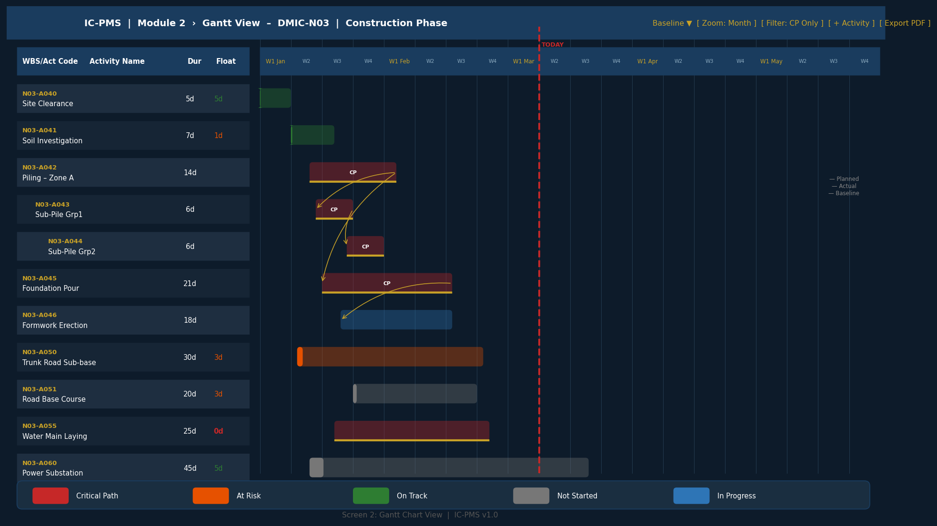
Figure 5.2 — Gantt Chart View (Activity List, Timeline, CP Highlighting, Dependency Arrows, Baseline Bars)

Gantt View — Key Interaction Design
Interaction | Behaviour | Visual Feedback
Click Gantt bar | Selects activity; loads detail in side panel | Bar highlighted with gold border; side panel slides in
Drag Gantt bar (Working baseline only) | Moves activity start/finish date; dependency chains auto-adjust | Ghost bar shows new position; conflicting constraints shown in red
Drag dependency arrow endpoint | Re-links predecessor/successor | New dependency line drawn; CPM re-runs; float values update live
Right-click bar | Context menu: Edit Activity, Add Predecessor, Add Successor, Assign Resource, Add Note, Progress Update | Context menu at cursor with icon-labelled actions
Zoom control (Month/Week/Day) | Changes timeline header granularity and bar width scale | Smooth animation; today line always centred
Filter: CP Only | Hides all non-critical activities from Gantt; shows only CP chain | Non-CP bars hidden; whitespace collapses; CP network visible
Baseline toggle | Overlays thin gold baseline bar below each current Gantt bar | Date variance visible as gap between bars; negative variance shows bar starting before baseline
Today line | Red vertical dashed line at current date | Always visible; auto-scrolls to today on screen load
Progress % entry | Click activity → inline progress slider or numeric entry | Bar fill updates live; EVM KPIs recalculate on save

Screen 3 — Activity Create / Edit Form
The six-tab Activity Form captures all attributes of a schedule activity in a structured wizard. The form maps directly to Oracle Primavera P6 activity attributes, ensuring XER compatibility. The PERT duration estimation panel is IC-PMS's unique extension for probabilistic planning.
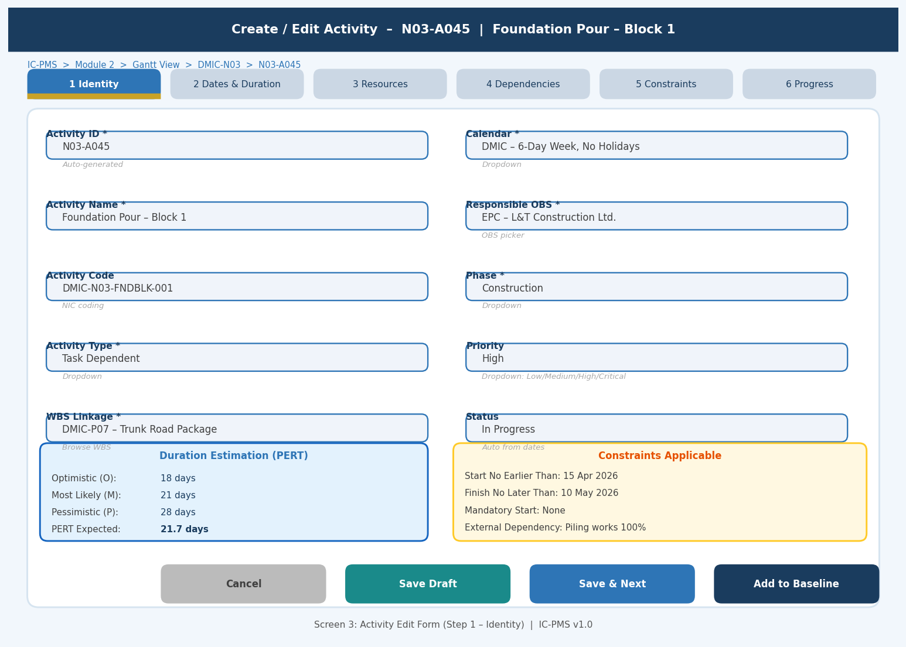
Figure 5.3 — Activity Edit Form (Step 1: Identity | PERT Duration Panel | Constraints Panel)

Form Tabs — Step Summary
Step | Title | Key Fields
Step 1 | Identity | Activity ID (auto), Name, Code, Activity Type, WBS linkage, Calendar, Responsible OBS, Phase, Priority, Status
Step 2 | Dates & Duration | Original Duration, Duration Type, Planned Start/Finish (or leave for CPM), PERT O/M/P estimates, PERT Expected (computed), Suspend/Resume dates
Step 3 | Resources | Resource search/add from Library, Planned Units per resource, Budgeted Cost per resource (auto-computed), Resource Calendar override
Step 4 | Dependencies | Add predecessor/successor (search by code or name), Dependency type (FS/SS/FF/SF), Lag/Lead days, External dependency flag
Step 5 | Constraints | Constraint type selector, Constraint date picker, Expected float impact calculation, Mandatory flag
Step 6 | Progress | Current % complete, Remaining duration, Actual Start/Finish dates, Progress source (Satellite/PMC/Contractor), Evidence attachment, Suspension flag

Screen 4 — Resource Manager
The Resource Manager displays all resource assignments across the selected schedule scope (project, node, or package) in a tabular view with embedded utilisation bar charts. Over-allocated resources are immediately visible in red. A resource histogram at the bottom shows monthly aggregate utilisation for the selected resource.
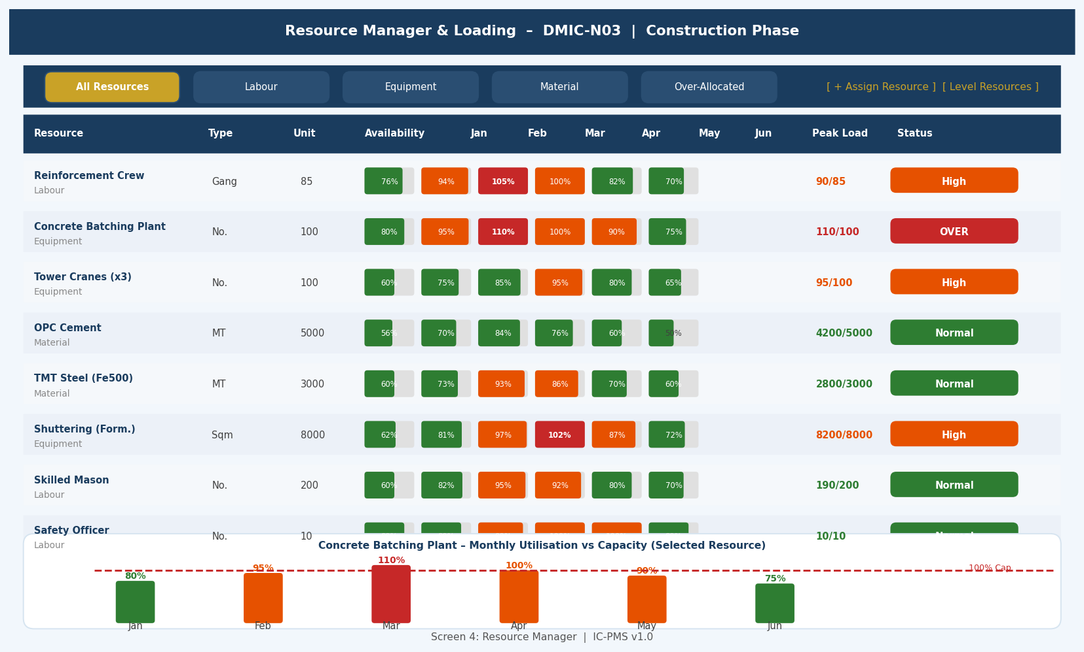
Figure 5.4 — Resource Manager (Allocation Table, Utilisation Bars, Monthly Histogram, Over-Allocation Alerts)

Resource Manager UI Features
Feature | Description
Resource filter tabs | Filter by All / Labour / Equipment / Material / Over-Allocated; multiple filters stackable
Availability vs. allocation columns | For each month: utilisation bar (green ≤85%, orange 85–100%, red >100%); numeric % shown inside bar
'Level Resources' button | Triggers automated resource levelling within available float; preview shows Before/After comparison
Peak Load column | Shows highest utilisation month with numeric value (e.g. 110/100 = 10% over-allocated)
Status badge | Green=Normal, Orange=High, Red=OVER-ALLOCATED — colour-coded badge in rightmost column
Resource histogram | Bottom panel: bar chart for selected resource showing monthly utilisation vs. 100% capacity line; red bars = over-allocated months
Click resource row | Loads resource detail: all activities this resource is assigned to, dates, planned vs. actual units
Assign Resource button | Opens resource search modal; filter by type/name/availability; drag to calendar to assign

Screen 5 — EVM Analytics Dashboard
The EVM Analytics Dashboard is the financial-performance view of the schedule — the screen most frequently used by NICDC Finance, Ministry officials, and lenders. It shows all EVM KPIs in large-format cards, a trend chart of BCWS/BCWP/ACWP over time with variance shading, and a package-level EVM comparison table.
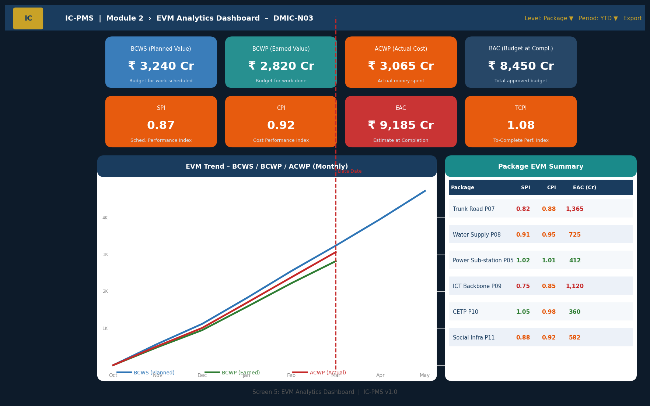
Figure 5.5 — EVM Analytics Dashboard (KPI Grid, BCWS/BCWP/ACWP Trend, Package EVM Table)

EVM Dashboard UI Components
Component | Description | Colour Logic
Top row: Absolute EVM values | BCWS, BCWP, ACWP, BAC shown as large cards with INR Crore values | Blue=BCWS, Teal=BCWP, Orange=ACWP, Navy=BAC
Second row: Derived KPI cards | SPI, CPI, EAC, TCPI shown with current value vs. target | Green if on threshold, Amber if approaching, Red if breached
BCWS/BCWP/ACWP Trend chart | Month-by-month line chart for all three EVM values. Shaded area between BCWP and ACWP = Cost Variance; between BCWP and BCWS = Schedule Variance. | CV shading: Red; SV shading: Amber; Lines: Blue/Green/Red
Package EVM table | Per-package SPI, CPI, EAC with traffic light colouring; sorted by worst CPI first | Individual cell colour: Green/Amber/Red based on thresholds in Section 2.6
Level/Period selectors | Switch EVM scope between Programme/Corridor/Node/Package; switch period between YTD/Current Month/Inception-to-Date | Selector changes all values and charts simultaneously
Export button | Generates EVM report PDF with all charts and tables for Ministry/lender distribution | PDF format; auto-dated with NICDC letterhead

6. Business Rules & Validation Logic

6.1 Scheduling Rules
Rule ID | Description | Outcome
SCH-001 | All activities must have at least one predecessor or be the first activity in the schedule (no orphan activities) | Warning on save; blocking error on Baseline submission
SCH-002 | Negative total float on the critical path must be resolved before the baseline can be approved | System shows infeasible activities in red; Constraint Resolver must be run
SCH-003 | Activity duration must be > 0 for Task Dependent and Resource Dependent types | Error: 'Duration must be at least 1 working day.'
SCH-004 | Actual Start date cannot be before the Project Planned Start date | Error if data entry violates; warning for out-of-sequence starts
SCH-005 | A Locked baseline cannot be modified; any edit creates a new version requiring re-approval | System prevents direct edit; prompts 'Create New Version' workflow
SCH-006 | Constraint violations (e.g. FNLT date earlier than CPM Early Finish) must generate negative float alerts | Alert shown in Constraint Resolver; blocking for baseline submission
SCH-007 | Resource loading is mandatory for all Work Package activities before baseline can be Submitted | Blocking: 'All Work Package activities must have at least one resource assigned.'
SCH-008 | EVM data date can only be advanced, never moved backward, once approved by NICDC Programme Manager | System enforces monotonically increasing data date; rollback requires NICDC admin approval

6.2 EVM Rules
Rule ID | Description | Outcome
EVM-001 | ACWP must be sourced from Module 4 certified invoice data; manual ACWP entry blocked except for NICDC Finance with override reason | Blocked unless Module 4 integration available; override logged in audit trail
EVM-002 | If SPI < 0.85 for two consecutive data dates, auto-generate Recovery Schedule request in Module 5 | Workflow trigger: recovery schedule to be submitted within 14 days
EVM-003 | If CPI < 0.85 for two consecutive data dates, auto-generate RCE (Revised Cost Estimate) notification to NICDC Finance | Notification with supporting EVM trend data; Module 4 RCE workflow initiated
EVM-004 | BCWP % complete must use satellite-derived progress unless PMC override is approved and documented | BCWP locked to satellite_progress_pct; override requires PMC certified_progress_pct entry with justification
EVM-005 | EVM calculations must be re-run within 24 hours of every data date advance | System auto-triggers EVM recalculation job on data date change; failure triggers alert to system admin

6.3 Baseline Rules
Rule ID | Description | Outcome
BSL-001 | Only one Current Approved Baseline (BL-CA) may exist per schedule at any time | System automatically archives previous BL-CA on approval of new revision
BSL-002 | A new baseline (BL-CA revision) requires an approved Root Cause Analysis document in Module 6 DMS | Blocking: 'RCA document must be uploaded and approved before new baseline can be set.'
BSL-003 | Baseline revisions that increase project duration by > 10% require NICDC Programme Director approval; > 20% require Ministry concurrence | Escalating approval chain triggered automatically based on duration change %
BSL-004 | What-If baselines (BL-WI) cannot be published as Current; they are analysis-only and expire after 90 days | System marks BL-WI as expired after 90 days; user must re-run if still needed

7. Integration Touchpoints

7.1 Internal Module Integrations
Module | Data Exchanged | Trigger / Frequency
Module 1 — WBS | Inbound: WBS hierarchy, element codes, baseline dates, responsible OBS; Outbound: Schedule confirmation, activity count per WBS | On WBS Publish from Module 1; auto-creates activity stubs
Module 3 — Satellite | Inbound: AI-derived physical % complete per WBS polygon; Outbound: WBS polygon codes and data date for scene ordering | Weekly satellite processing cycle; real-time on-demand query
Module 4 — Cost Mgmt | Inbound: ACWP from certified invoices; Outbound: BCWS time-phased budget, EAC, activity-level planned cost | Monthly RA Bill cycle; real-time on data date advance
Module 5 — Contract Mgmt | Outbound: Schedule milestone dates for contractual payment triggers, LD calculation dates; Inbound: Contract award dates as schedule constraints | On contract award; on milestone completion
Module 6 — DMS | Outbound: Schedule reports, Gantt PDFs, RCA document requests; Inbound: RCA approval status for baseline revision | On demand; on baseline revision workflow
Module 7 — Risk | Inbound: High-probability risks linked to schedule activities as PERT pessimistic adjustments; Outbound: Schedule float data for risk exposure calculation | Monthly risk review cycle
Module 9 — Reporting | Outbound: All EVM metrics, S-curve data, critical path summary, schedule health index for executive dashboards and MPR | Real-time read on every data date advance

7.2 External System Integrations
System | Integration | Data Flow | Format
Oracle Primavera P6 | Bidirectional XER import/export | Schedule import from P6 (WBS, activities, resources, baselines); schedule export to P6 for planners using P6 desktop | Primavera XER v20+
MS Project | Bidirectional XML import/export | Schedule import from .mpp/.xml; export to .xml for sharing with stakeholders using MS Project | MS Project XML 2016+
PFMS (CGA) | REST API — read ACWP | Invoice-confirmed payment amounts pulled for ACWP computation | JSON over HTTPS
WhatsApp Business API | Outbound push — look-ahead | 4-week look-ahead condensed summary pushed to field supervisor WhatsApp groups every Monday 8 AM | Text + PDF attachment
Power BI / Tableau | REST/ODBC — read-only | EVM metrics, S-curve data, health index exposed for BI dashboards at Ministry level | JSON API / ODBC connector

8. Workflow & Approval Chains

8.1 Schedule Approval Lifecycle
State | Entry Condition | Actions Permitted | Exit to Next State
Draft | Schedule created by PMC Planner | Add/edit activities, assign resources, run CPM | All activities resource-loaded; PMC Lead submits
Submitted | Validation passes; submitted by PMC Lead | View only; withdraw to Draft for corrections | SPV Director reviews and approves
Approved | SPV Director approval received | View only; data date advance permitted | NICDC countersign for schedules with EAC > ₹500 Cr
Current (Active) | Final approval; BL-CA locked | Progress update, data date advance, look-ahead, EVM | Revision approved → new BL-CA; project closed → Archived
Archived | Project phase complete or superseded by revision | Read only — historical reference | Terminal state

8.2 Baseline Revision Approval Chain
Revision Trigger | Duration Change | Cost Impact | Approver Chain
Schedule optimisation (no scope change) | < 5% change | None | SPV PM + SPV Director
Minor scope addition (VO < 10%) | 5–10% change | VO value linked | SPV Director + NICDC PM Director
Significant scope change / external delay | 10–20% change | RCE required | SPV Director + NICDC MD + Ministry note
Major scope change / force majeure | > 20% change | Full RCE + CCEA note | Cabinet committee informed
Emergency Recovery Schedule | Any — expedited | Crash cost analysis required | NICDC MD fast-track (3-day turnaround)

9. Schedule Health Index (SHI) — IC-PMS Innovation
The Schedule Health Index is a composite KPI unique to IC-PMS, synthesising multiple schedule quality and performance signals into a single 0–100 score. It goes beyond EVM's SPI by also reflecting schedule structural quality (float distribution, critical path length) and progress data quality (satellite vs. contractor agreement).

9.1 SHI Components & Weights
Component | Weight | Calculation | Green Threshold
SPI Score | 25% | SPI × 25 (capped at 25 if SPI ≥ 1.0) | SPI ≥ 0.95 → score ≥ 23.75
Critical Path Ratio | 20% | (1 – CP_activities/total_activities) × 20 | CP ratio ≤ 15% → score ≥ 17
Float Distribution | 15% | % activities with TF > 14 days × 15 | ≥ 70% with adequate float → ≥ 10.5
Resource Loading Quality | 15% | % activities with ≥ 1 resource assigned × 15 | 100% resource-loaded → 15
Baseline Stability | 10% | (1 – no. of baseline revisions / 5) × 10 | ≤ 2 revisions → score ≥ 6
Satellite-Contractor Agreement | 10% | % activities where |satellite – contractor| ≤ 10% × 10 | ≥ 90% agreement → ≥ 9
Look-ahead Completeness | 5% | % weekly look-aheads submitted on time × 5 | 100% on-time → 5

9.2 SHI Thresholds
SHI Range | Status | Dashboard Colour | Action
85–100 | Excellent | Green | No action required; celebrate milestone
70–84 | Good | Teal | Monitor; investigate lowest-scoring components
55–69 | At Risk | Amber | SPV Director review; improvement plan within 14 days
40–54 | Poor | Orange | NICDC Programme Director intervention; recovery schedule
< 40 | Critical | Red | NICDC MD escalation; possible PMC performance review

10. Glossary — Module 2 Terms
Term | Definition
CPM | Critical Path Method — deterministic scheduling technique computing earliest/latest dates and float for each activity
PERT | Programme Evaluation & Review Technique — probabilistic duration estimation using three-point estimates
EVM | Earned Value Management — integrated scope/schedule/cost performance measurement methodology (ANSI/EIA-748)
BCWS | Budget Cost of Work Scheduled — Planned Value; budget authorised for work planned to be done by a point in time
BCWP | Budget Cost of Work Performed — Earned Value; budget value of work actually completed to date
ACWP | Actual Cost of Work Performed — actual money spent on work completed to date (from certified invoices)
SPI | Schedule Performance Index = BCWP / BCWS; value < 1 means behind schedule
CPI | Cost Performance Index = BCWP / ACWP; value < 1 means over budget
EAC | Estimate At Completion — predicted total cost at project end = BAC / CPI
TCPI | To-Complete Performance Index = (BAC–BCWP)/(BAC–ACWP); efficiency required to finish on budget
BAC | Budget At Completion — total approved project budget (sum of all baseline activity budgets)
Total Float | Latest allowable time to start/finish minus earliest time; zero = critical activity
Free Float | Time an activity can be delayed without delaying its immediate successors
Forward Pass | CPM calculation to find earliest start/finish for each activity
Backward Pass | CPM calculation to find latest start/finish for each activity
P50 / P80 | Probabilistic completion date with 50% / 80% confidence from Monte Carlo simulation
XER | Oracle Primavera P6 native schedule export format (XML-like text file)
Data Date | The schedule statusing date — all EVM calculations are as of this date
BL-CA | Current Approved Baseline — the latest locked reference schedule used for EVM variance calculation
SHI | Schedule Health Index — IC-PMS composite schedule quality and performance score (0–100)

